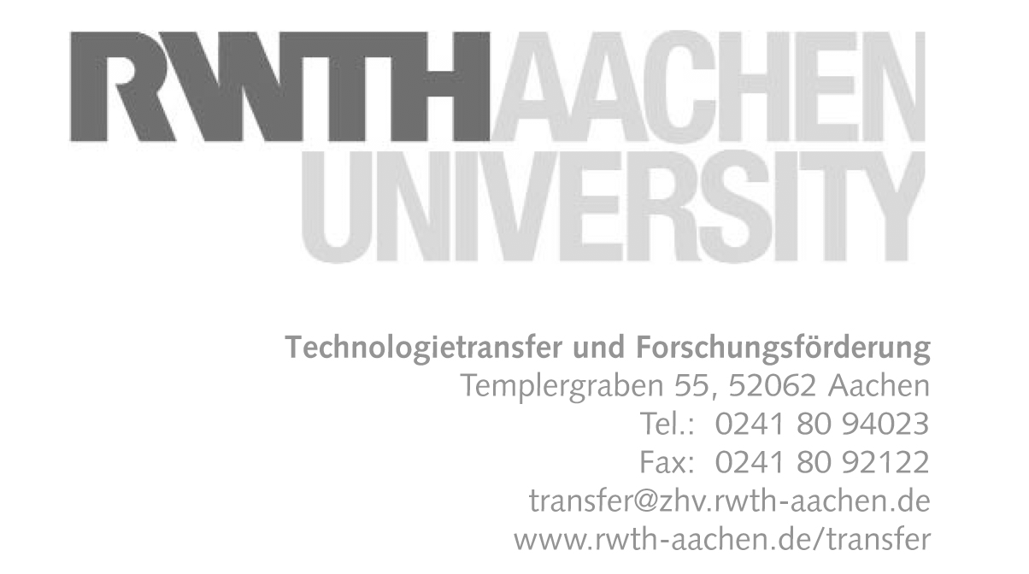

Visit of a delegation from

Southeast University Nanjing
on September 30th 2009, 10:00-12:00

RWTH Aachen, Super C, Room 5.30

Agenda

10:00 | Welcome and introduction of RWTH Aachen  Univ.-Prof. Dr.rer.nat. Michael Vorländer  Dean FB6 | Super C, Raum 5.30  RWTH Aachen
10:10 | Overview on the activities of the Faculty of Electrical Engineering and Information Technology (FB6)  Univ.-Prof. Dr.rer.nat. Michael Vorländer  Dean FB6 | Super C, Raum 5.30  RWTH Aachen
10:40 | Overview on the activities of the Faculty of Mechanical Engineering (FB4)  Univ.-Prof. Dr.-Ing. Michael Modigell  Vice dean FB4 | Super C, Raum 5.30  RWTH Aachen
11:10 | Introduction of Southeast University Nanjing and presentation of main activities  (who is the presenter?) | Super C, Raum 5.30  RWTH Aachen
11:40 | Discussion of collaboration issues | Super C, Raum 5.30  RWTH Aachen
12:00 | End of visit of RWTH Aachen

Participants of the delegation of Southeast University Nanjing:

1. Prof. Shen Jiong, vice president of SEU, his research field is thermal engineering and
thermal process control
2. Prof. Li Jianqing, dean of scientific research department of SEU, his research field is
"Measurement and Control Technology and Instruments", especially for Distributed Wireless
Sensor Networks, Robot Sensing and Control Technology
3. Prof. Chen Yongping, vice director of international affairs of SEU, his research field is MEMS
and Thermal Engineering
4. Associate Prof. Liu Lu, teacher in the School of Science and Engineering. Her research field
is display technology and visual perception.
5. Prof. Lei Wei, School of Science and Engineering. Research fields are display technologies
and nanocathodes

and Dr. Georg Gärtner, Philips Research Laboratories Europe – Aachen,
Visiting Professor of Southeast University Nanjing

Participants from RWTH Aachen:

1. Univ.-Prof. Dr.rer.nat. Michael Vorländer, Dean FB6 :
Faculty of Electrical Engineering and Information Technology

2. Univ.-Prof. Dr.-Ing. Michael Modigell, Vice dean FB4 :
Faculty of Mechanical Engineering

3. Prof. Dirk Heberling, Institute of High Frequency Technology, FB6

4. Dipl.-Kff. Eleonor Thompson, Technology and Innovation Transfer

For more information on RWTH see e.g. :
http://www.fb6.rwth-aachen.de/en/5.php and http://www.maschinenbau.rwth-aachen.de/en/institutes.html

