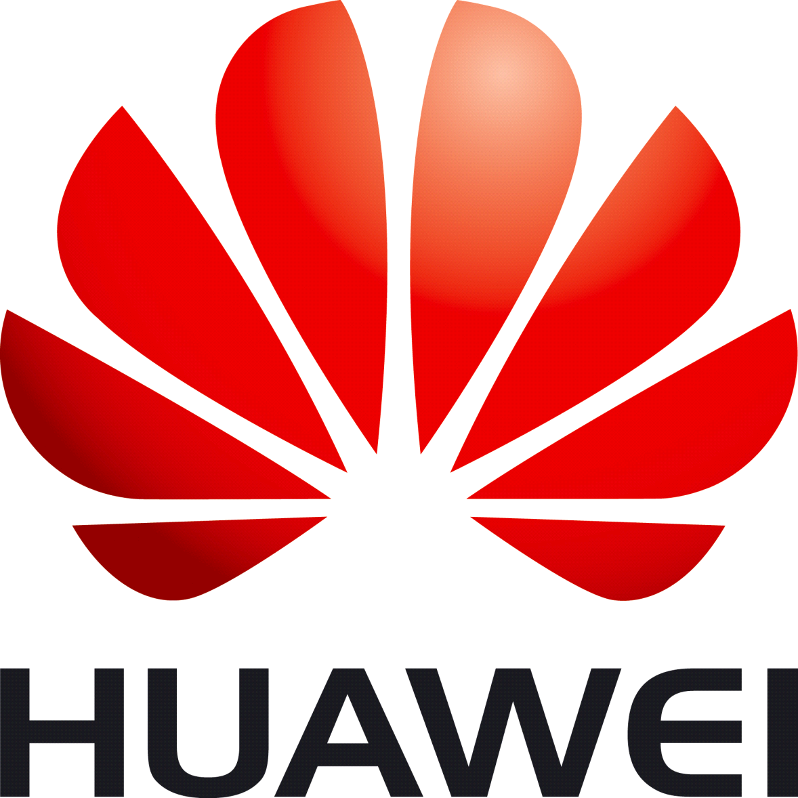

To Grow-up with Huawei Technologies:
Taking the Opportunity to Success

职位名称： 业务管理助理（实习生）

公司名称：华为科技杜塞尔多夫有限公司

部门名称：欧洲Marketing

工作地点：德国杜塞尔多夫

招聘人数：1名

工作内容：
You will be responsible for helping manager to operate and manage the business data and routine work of HR, acting as an assistant for business management and human resource management:
  - To work with all team members to collect and make statistics of business data and deliver some business documents as the uniform delivery platform.
  - To assist HR manager to organize and monitor quarter performance appraisal and update the information of HR and etc.
  - To charge of some routine work in business management department, such as organize the meeting to study company document and security policy
  - Responsible for construction and maintenance EU Marketing platform, including but not limited to folder management, upload some documents and enhance document sharing through platform, etc.

资格要求：
- Information management，Economics, Secretary or Language background.
- To be an effective organizer and communicator with good interpersonal skills, flexible conscientious attitude, and team spirit.
- Good in speaking, reading and writing English.
- Other European language capabilities will be a plus.

联系方式：
如果您对此职位感兴趣，欢迎把中、英文简历发至yucungao@huawei.com ，
Mr.于 收
请在来信中注明应聘职位

